**Project Design Phase-II Data Flow Diagram & User Stories**

|  |  |  |  |  |  |  |
| --- | --- | --- | --- | --- | --- | --- |
| **User Type** | **Functional Requirement (Epic)** | **User Story Number** | **User Story / Task** | **Acceptance criteria** | **Priority** | **Release** |
| Patient | View Health Reports | USN-1 | As a patient, I want to view my heart disease risk score. | The patient can see a visual representation of their heart disease risk score. | High | Sprint 1 |
| Doctor | Access Patient data | USN-2 | As a doctor, I want to access and review my patient's heart disease risk scores and reports. | The doctor can access patient profiles.  The doctor can view detailed reports of the patient's heart disease risk.  The doctor can set alerts for critical patient risk levels. | High | Sprint-2 |
| Data Analyst | Data Analysis | USN-3 | As a data analyst, I want to analyze heart disease risk data for research purposes. | The data analyst can access and export anonymized data.  The data analyst can generate visualizations and reports for research.  The data analyst can filter and segment data for specific studies. | Medium | Sprint 2 |

**Data Flow Diagram:**

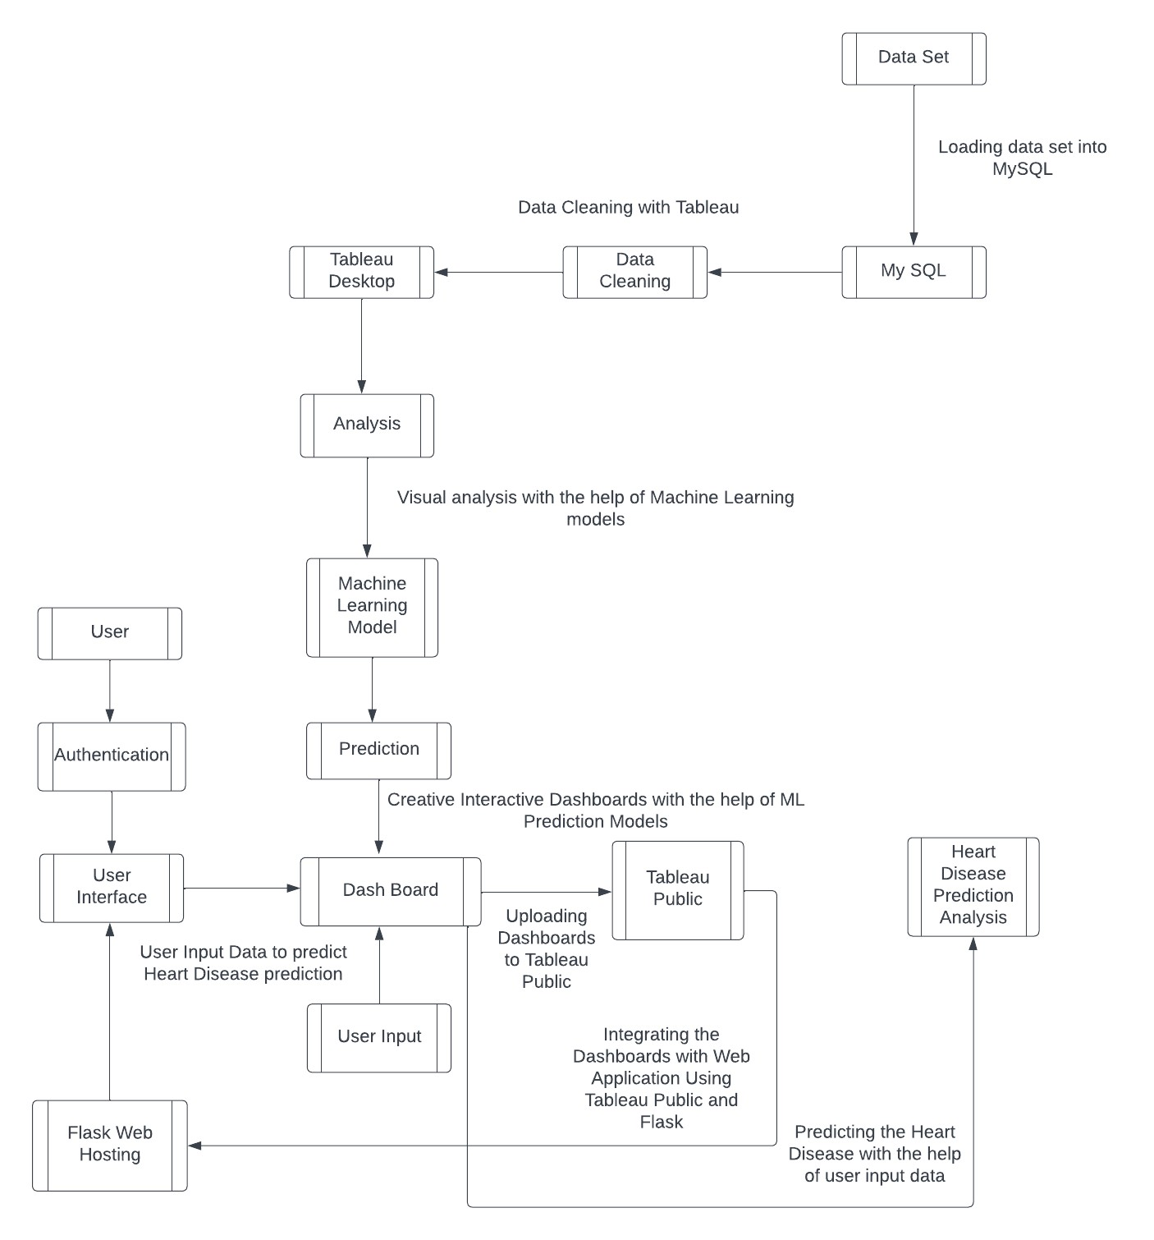

**User Stories:**

|  |  |  |  |  |  |  |
| --- | --- | --- | --- | --- | --- | --- |
| Admin | Manage Users | USN-4 | As an admin, I want to manage user accounts and access control. | The admin can add, modify, or delete user accounts.  The admin can assign roles and permissions to users. | Medium | Sprint 2 |
| Care Giver | Monitors Patient Data | USN-5 | As a caregiver, I want to monitor the health data of the patient I care for. | The caregiver can access the patient's health reports.  The caregiver can receive alerts in case of critical risk levels.  The caregiver can communicate with the patient's doctor. | Low | Sprint 3 |